

**Safety Rules and Instructions**

**For**

**Aluminium Mobile Scaffolding**

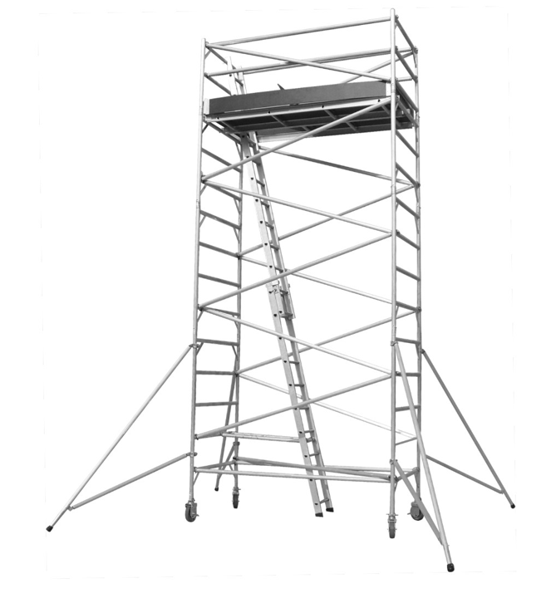Interior or Exterior Use

**WARNING**

* Improper assembly, disassembly, or use of the Multi-Use Scaffold can lead to serious injury or death. Individuals assembling, disassembling, or using the Multi-Use Scaffold must thoroughly read and understand these Safety Rules & Instructions as well as the relevant OH&S regulations before use.
* If the fall height from the scaffold's top working platform exceeds 4 meters, anyone involved in erecting, modifying, or dismantling the scaffold at that platform must possess a valid scaffolding certification.

**LOAD CAPACITIES**

2.5 meter Lenth Unit

Light duty rates-225kg SWL (each platform)

Maximum Load 450kg (WORKERS & MATERIALS)

*WARNING! DO NOT OVERLOAD SCAFFOLD, MAY RESULT IN SERIOUS INJURY!*

**ASSEMBLY INSTRUCTIONS**

For proper assembly, your Aluminium-6 Scaffold must be made up of 40 individual parts (as per drawing)

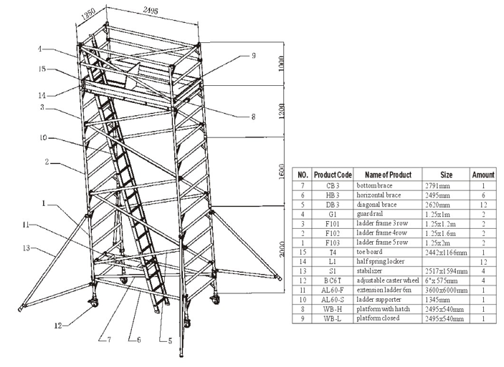

1. Attach the casters to the screw jacks, then secure the jacks to the bottom ladder frames. Keep the screw jacks extended to 100mm. Ensure the caster brakes are engaged before beginning scaffold assembly.

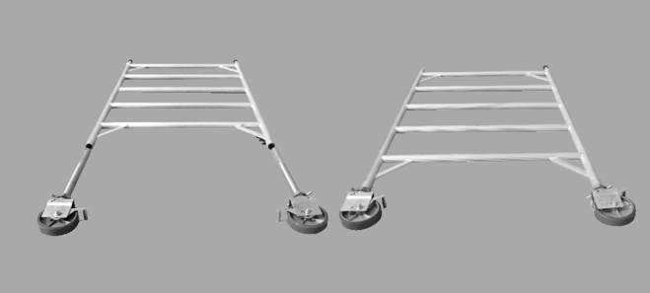

1. Connect two horizontal braces to the first row of the ladder frame. Then, attach the bottom brace to the diagonal vertical tube of the ladder frame. This will make the frame self-supporting.

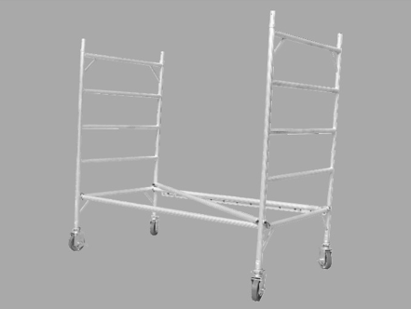

1. Attach two diagonal braces to the second and fourth rows of the ladder frame. Next, attach the stabilizers to the vertical tubes of the ladder frame.

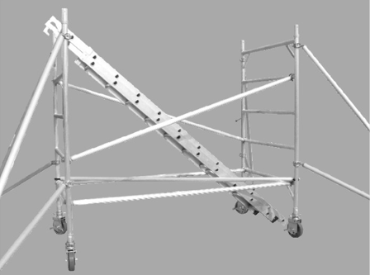

1. Insert the extension ladder into the scaffold.

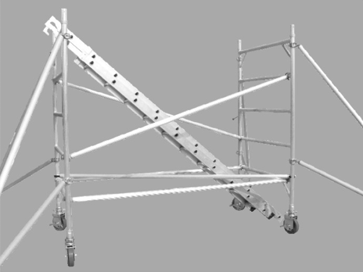

1. Secure the second four-row ladder frame to the first ladder frame and lock the spigot. Then, attach two diagonal braces to the second ladder frame.

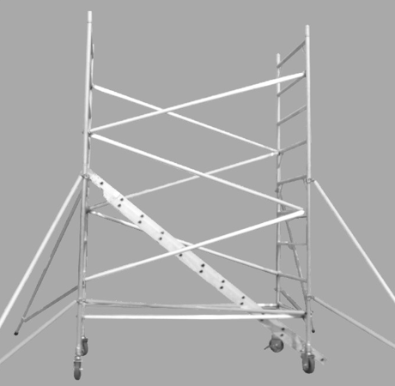

1. Fit the extension ladder to the fourth row of the four-row ladder frame. Attach the third-row ladder frame to the second ladder frame and add two diagonal braces.

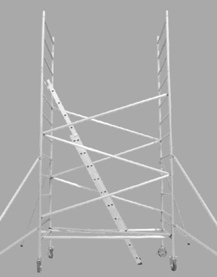

1. Attach two diagonal braces to the ladder frame.

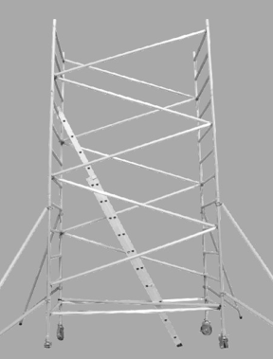

1. Install the guard rail on the third-row ladder frame, then attach the platform with hatch to the same frame.

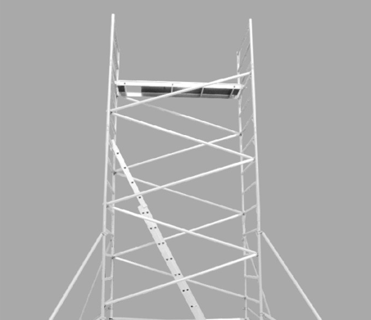

1. Fit the extension ladder to the top of the guard rail, ensuring it passes through the hatch of the platform.

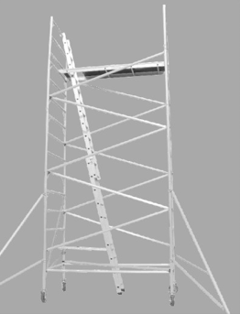

**WARNING**

Both side braces must be at the same height on the frames to keep the platform level.

Ensure all four L-shaped lock pins are fully engaged and locked in the frame holes.

1. Place the second platform next to the guard rail, adjacent to the first platform.

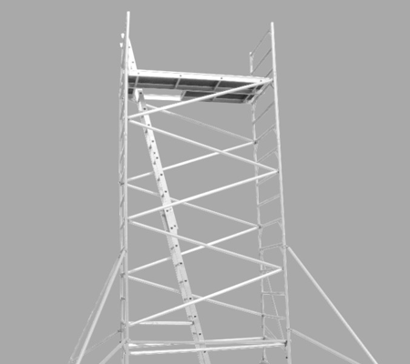

1. Attach two horizontal braces to the second and third rows of the guard rail.

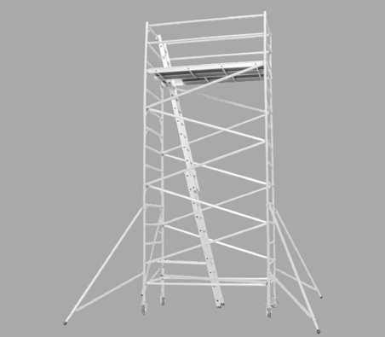

1. Install the toe board on top of the platform.

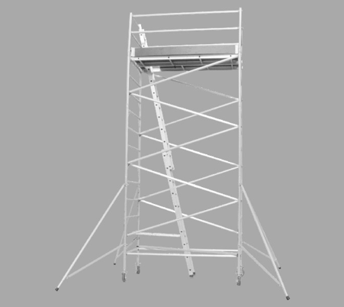

1. Attach two diagonal braces to the guard rail.

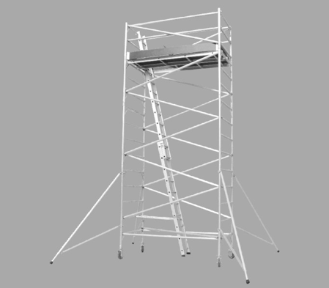

1. Before using the scaffold tower, ensure that the stabilizers are firmly in contact with the ground.

**Dismantling:** Follow the reverse process of assembly.

**\*\*WARNING\*\***

- Verify that all side brace lock pins are fully engaged before using the platform.

- Ensure the platform is properly seated within the side brace channel and that the platform clips are securely engaged before use.

- When accessing the platform, climb directly over the top of the frame ladder—**DO NOT swing around the side of the frame.**

|  |  |
| --- | --- |
| **\*\*TYPICAL APPLICATIONS INCLUDE:\*\*** | |
| - Painting | - Window Cleaning & Treatment Installation |
| - Sign Installation & Maintenance | - General Building Maintenance |
| - Acoustical Ceilings | - HVAC Installation |
| - Overhead Door Installation | - Functions as shelving |
| - Drywall Installation & Taping | - And more |
| - Lighting & Electrical Maintenance |  |

**DISMANTLING NOTES**

Dismantling scaffolding should be overseen by a qualified and experienced individual. Follow these guidelines to ensure safety during the process:

1. **Responsibility:** Ensure you read and follow these safety guidelines, which are designed to promote safe dismantling practices.
2. **Inspection:** Check if the scaffold has been structurally altered in any way that could compromise safety. If alterations are found, make necessary repairs before beginning dismantling.
3. **Top-Down Dismantling:** Disassemble the scaffold from the top down, removing all accessories from the section being dismantled.
4. **Ties and Braces:** On stacked scaffolds, do not remove ties and braces until dismantling has progressed to the section they are attached to.
5. **Work Area:** Always work from within the scaffold structure.
6. **Climbing:** When moving up or down the scaffold, avoid climbing on ties, braces, or non-braced components. Climb over the top of the frame and do not swing around the outside.
7. **Clear Area:** Ensure the area below the scaffold is clear of unauthorized personnel, and secure the ground to prevent unauthorized access.
8. **Controlled Lowering:** Lower scaffold components in a controlled manner. Avoid dropping or throwing components to prevent injury or damage.
9. **Safety Equipment:** Use energy-absorbing lanyards and a full-body harness when required by law.

**SCAFFOLD SAFETY RULES**

Improper assembly or use of scaffold equipment can result in serious injury or death. Assemblers and users must adhere to these safety rules and practices. These guidelines address general safety issues and should be supplemented with any additional measures necessary for specific conditions encountered during installation or dismantling. Always comply with OH&S laws and other relevant regulations.

|  |  |
| --- | --- |
| A. **\*\*Adhere to Safe Practices:\*\*** Follow the safety rules and comply with OH&S laws and all federal, state, and local regulations related to scaffolding. | F. **\*\*Maintain Equipment:\*\*** Keep all equipment in good repair. Avoid using corroded or excessively rusted components, as their strength is uncertain. |
| B. **\*\*Training and Supervision:\*\*** Ensure all personnel involved in scaffolding assembly are trained in safety procedures and supervised by someone with adequate experience. Display these Safety Rules where they are visible to all users. | G. **\*\*Consult Your Supplier:\*\*** If in doubt about any aspect of the scaffold, consult your supplier. Never take unnecessary risks. |
| C. **\*\*Report Unsafe Conditions:\*\*** Notify supervisors of any unsafe conditions. Do not allow individuals who are ill, dizzy, or otherwise impaired to work on the scaffold. | H. **\*\*Read Safety Rules:\*\*** Always review these Safety Rules alongside all applicable safety regulations. |
| D. **\*\*Inspect Equipment:\*\*** Before use, check all equipment for damage or defects. Do not use any equipment that is compromised. | I. **\*\*Stable Surface:\*\*** Place scaffolds on a stable, solid surface capable of supporting the intended loads. Avoid placing scaffolds on unstable ground where loose objects could cause instability. |
| E. **\*\*Regular Inspections:\*\*** Frequently inspect the assembled scaffold to ensure it remains in a safe condition. Verify that connections are secure and no components have been improperly adjusted or removed.  K. **\*\*Proper Tying:\*\*** Ensure that the scaffold is properly tied or anchored to a structure that can support all loads. This is crucial for scaffold stability and safety. | J. **\*\*Handle Components Safely:\*\*** Lift and lower scaffold components carefully. Use tag lines if needed. Avoid overloading partially completed scaffolds and promptly lower dismantled components. Do not drop components. |
| L. **\*\*Stabilization:\*\*** Free-standing scaffolds, other than wall scaffolds, must be secured with guying or other stabilization methods to prevent tipping. | Q. **\*\*Mobile Scaffolds:\*\*** Follow these additional safety rules for mobile scaffolds:   * + Never ride on mobile scaffolds.   + Remove all materials and equipment before moving the scaffold.   + Lock castor and outrigger brakes when the scaffold is stationary.   + Move mobile scaffolds only with sufficient assistance and on even surfaces. Watch for surface hazards and overhead obstructions.   + Do not exceed the maximum platform height for mobile scaffolds. Comply with all OH&S laws.   + Move the scaffold by using the bottom frame. Never attempt to move it while on top.   + If using mobile scaffolds outdoors, ensure they are stable against wind and other environmental conditions.   + **Avoid Overloading:** Do not exceed the scaffold's load capacities. Always refer to and adhere to the specified limits. |
| M. **\*\*Install Safety Features:\*\*** Install guardrails, midrails, and toe boards at all openings, open sides, and ends of work platforms. |
| N. **\*\*Avoid Makeshift Solutions:\*\*** Do not use ladders or other makeshift devices to increase scaffold height. Avoid standing on guardrails or midrails. |
| O. **\*\*Power Lines:\*\*** Exercise extreme caution around power lines. Consult with the electrical company to de-energize, insulate, or otherwise make power lines safe before installing or using scaffolds. |
| P. **\*\*Cantilevers:\*\*** When using cantilevers such as brackets, take proper precautions to prevent scaffold tipping. |